Git commands

# Git clone:

Git clone command is used to create a copy of an existing repository to download all files and branches to the local repository from remote repository.it will allowing you to work on that project.

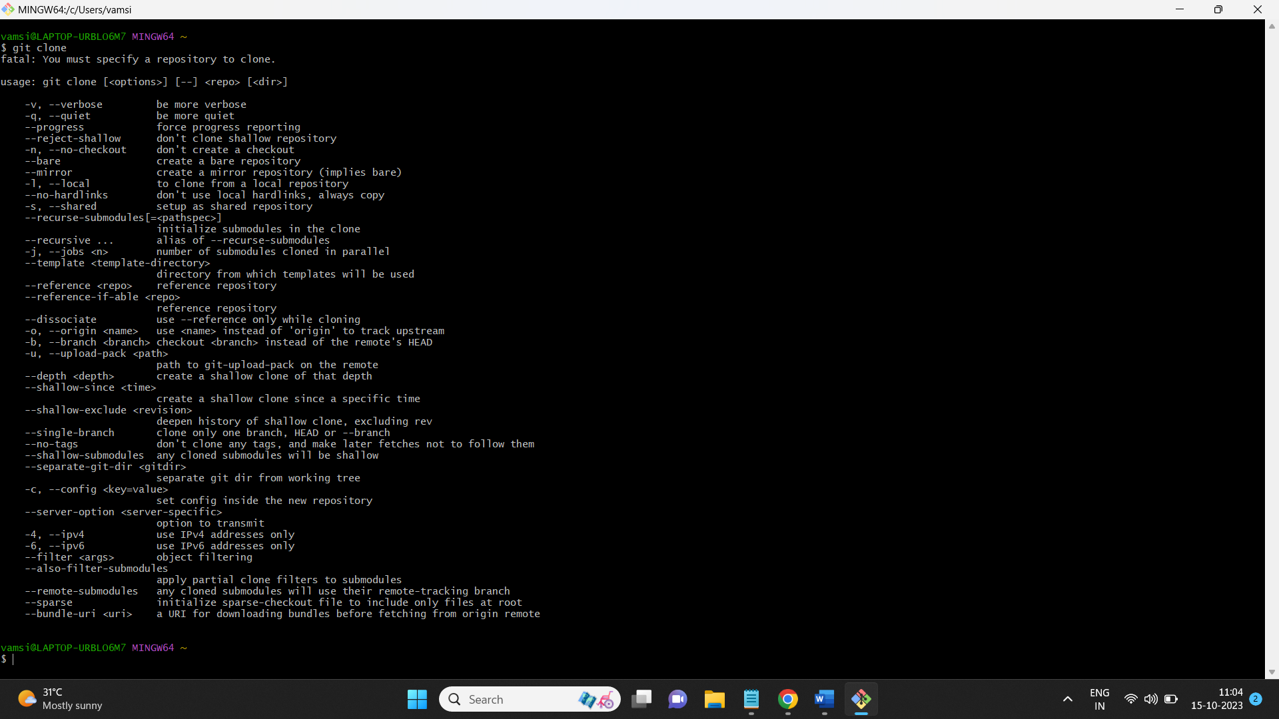

When we use only “git clone” it will not clone the remote repository in this case we also mention the repository link along with the git clone command.

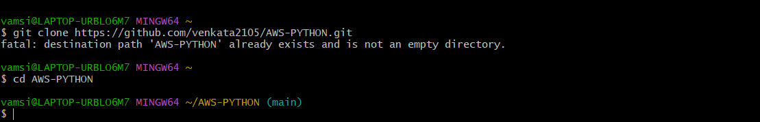

Now It will clone the remote repository files to the local repository.

# Git pull:

The git pull command is used to fetch the changes from the remote repository to the local repository of branches,basically it is used to save the changes amoung all the repositories by using git pull command. In some cases we can use remote name and branch name where we can save the changes (it is optional).

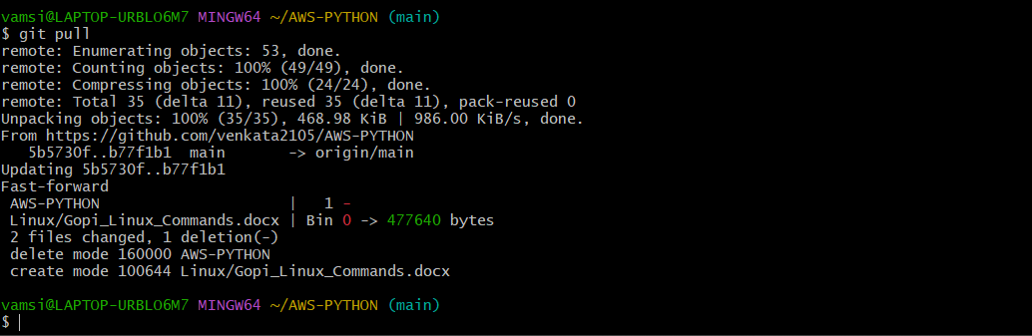

# Git add .:

The git add command is used to add the changes of a file or save new file to the branch and remote repository.in this case we can also use specific file name to save the changes, like git add<filename> and also we can mention multiple file names to save the changes of a file to the repository.

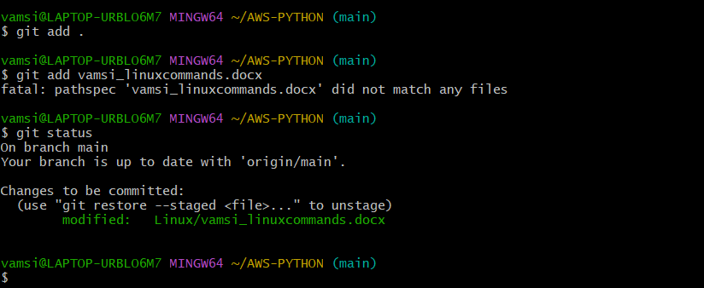

# Git commit -m “ “:

The git commit command in git is used to save the changes in a repository.it takes the snapshot of a repository to where the changes can made and also the -m is used to display the comments of the changes. After the stage of repository the commit will waiting for the upload of file with the work update in comments.

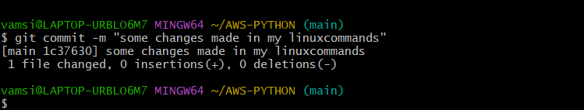

# Git push:

The git push command in git is used to upload the local repository changes to the remote repository, by uploading this every member of a remote repository will access the file.

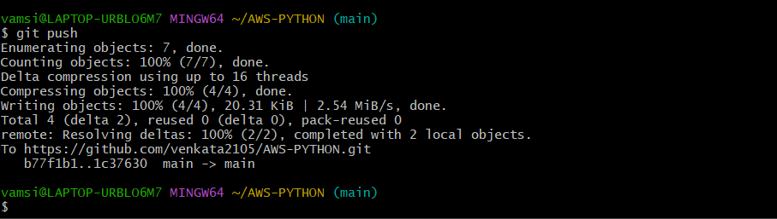

# Git fetch:

The git fetch command is used to fetch the changes from the remote repository, but it will not affect on the local repository. It used to view the which changes can made after viewing the changes if you want to create that changes into you local repository you can use merge command of git then the changes of remote repository will download to the local repository.

